Code Challenge Solution

## How to Run

Go to project root dir

cd ./business

mvn spring-boot:run

cd ../gui

npm run serve-dev

use browser: localhost:8080

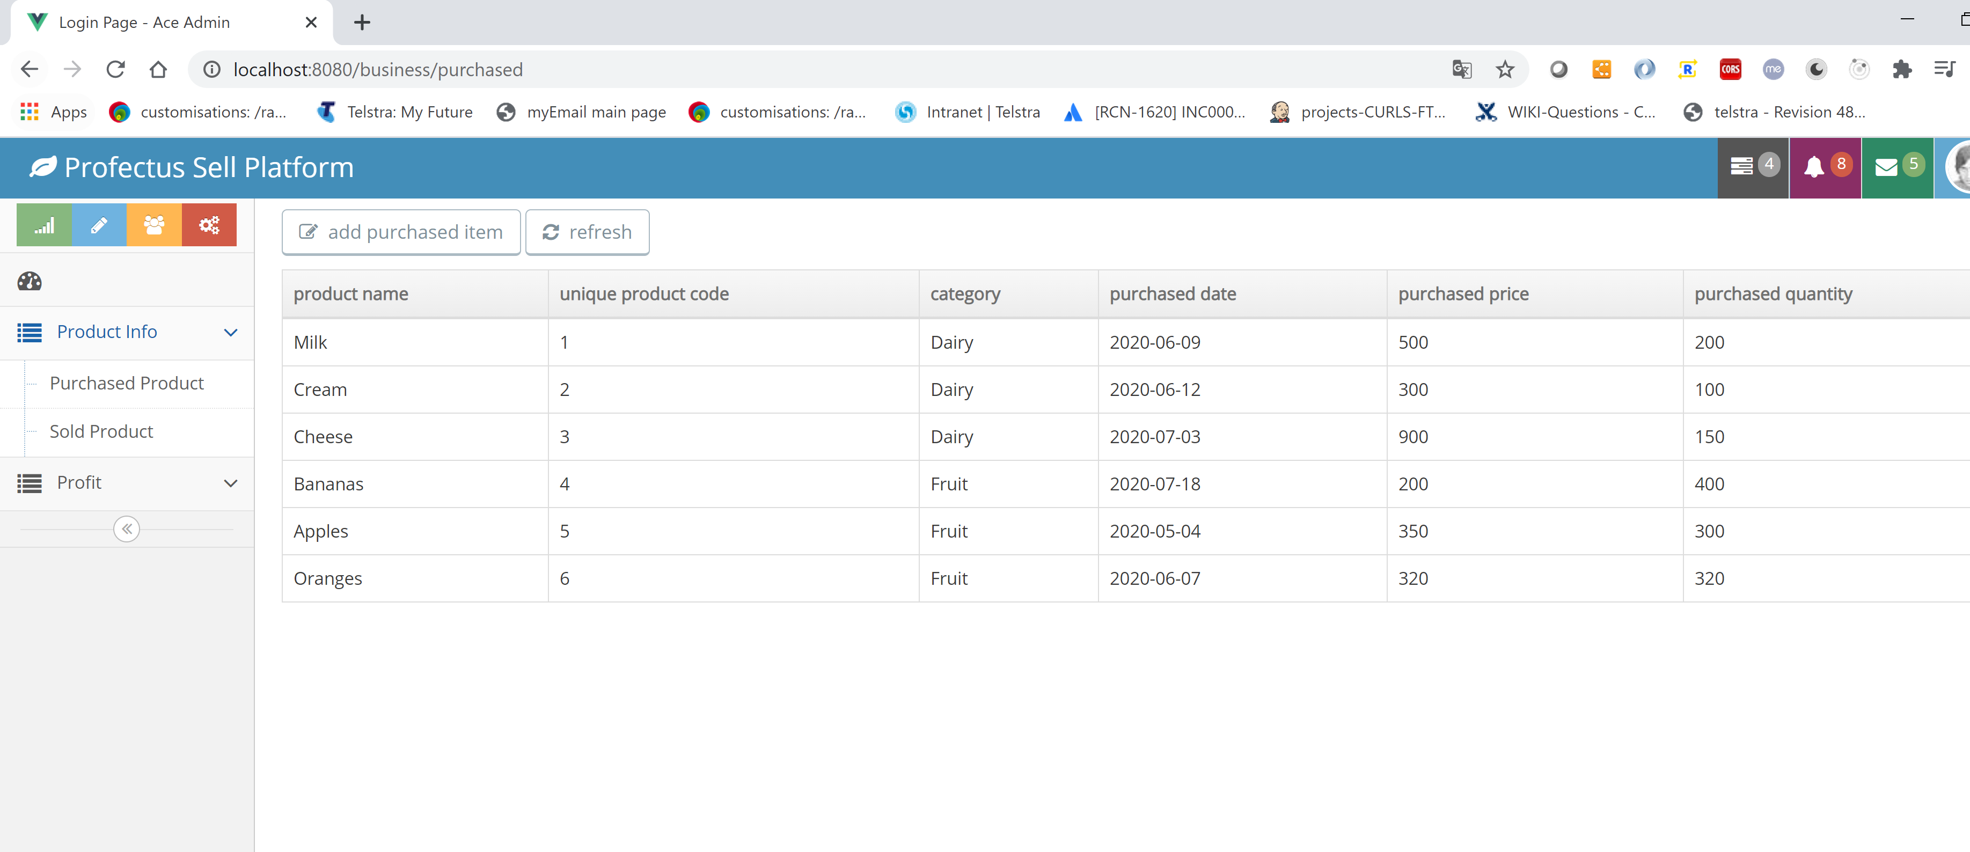

## GUI instructions

Click left menu bar to switch the page:

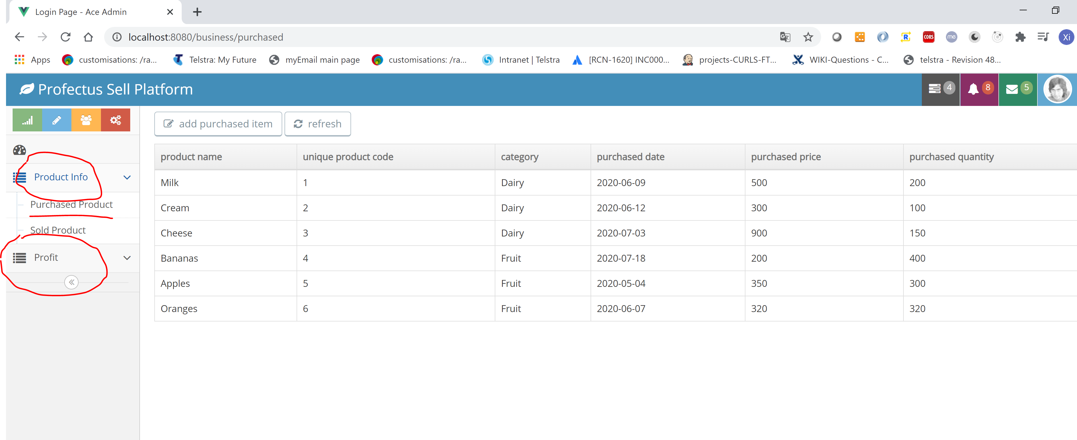

Add Purchased and Sold record through top left button:

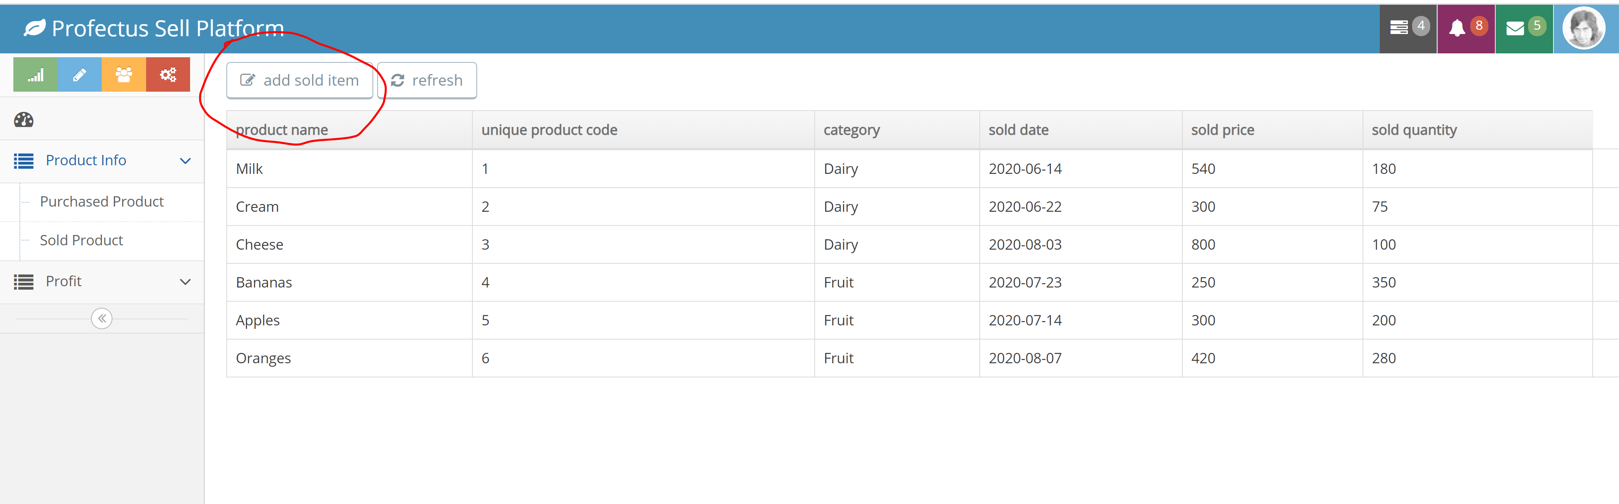

Get profit based on search conditions:

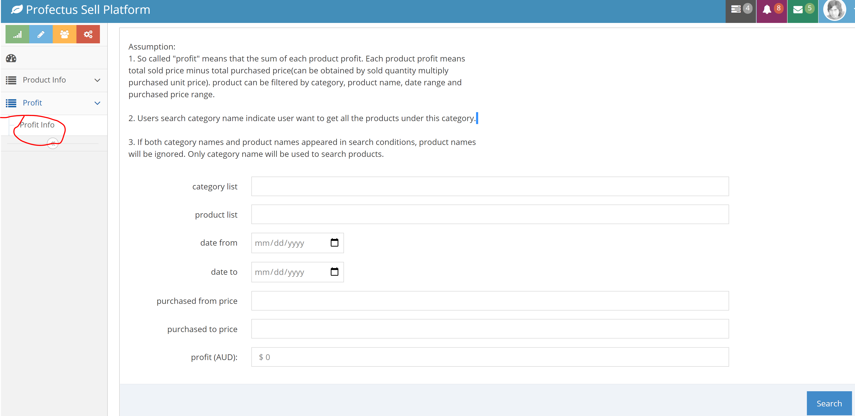

## Assumptions:

1. So called "profit" means that the sum of each product profit. Each product profit means one product sold total

price minus its own cost of these sold product which can be obtained by that sold quantity multiply purchased unit price.

Purchased unit price can be calculated as weighed average cost ( each product total purchased cost divide by total purchased quantity ).

Product can be filtered by category, product name, date range and purchased price range.

For example:

User want to get the profit of 2020 June Milk

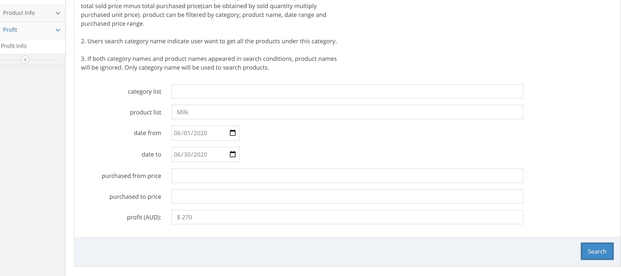

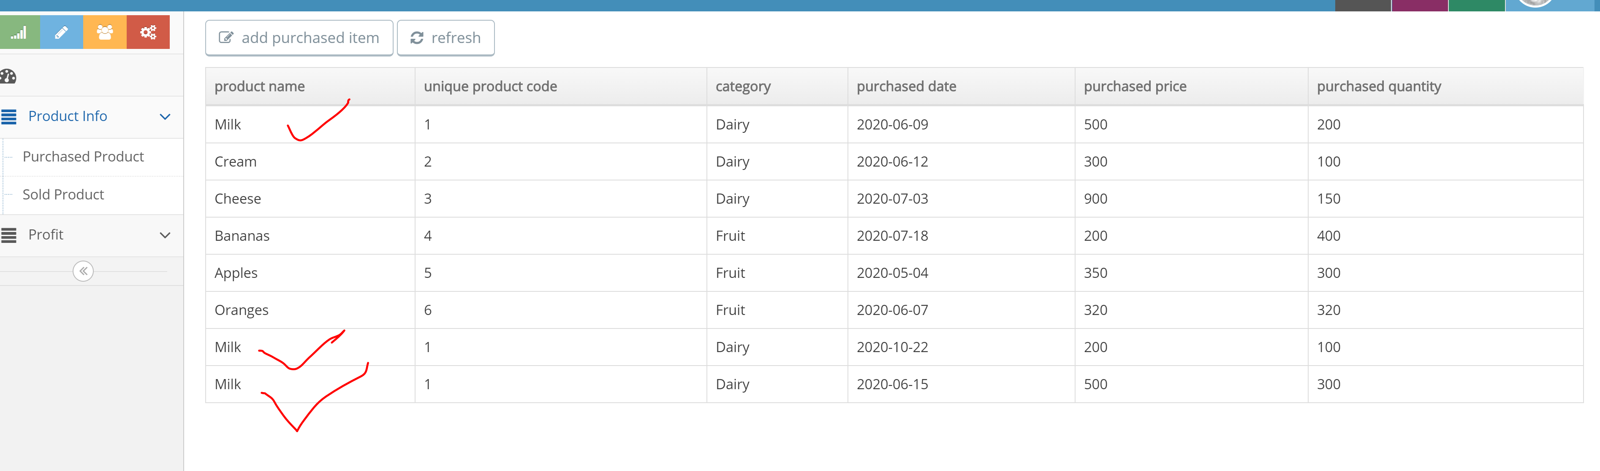

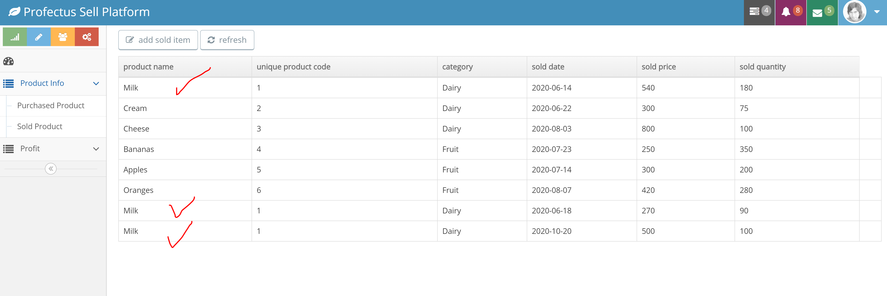

* Purchased unit price will be calculated firstly using weighed average cost. Based on above purchased table, purchased unit price = (500 + 500 + 300) / (200 + 300 + 150 ) = 2.00, the purchased record in Oct 2020 will be ignored and all the purchased date before June 2020 will be taken into account , because the search conditions only focus on 2020 as above screenshot shows.
* The total sold price will be ( 540 + 270) = 840 , total sold quantity is (180 + 90) = 270
* The profit will be total sold price – unit purchased price * total sold quantity = 840 – 270 * 2 = 270
* If search conditions include purchased price range, the unit purchased price known as weighted average cost will be calculated based on the filtered purchased record.

2. Users search category name indicate user want to get all the products under this category.

3. If both category names and product names appeared in search conditions, product names will be

ignored. Only category name will be used to search products.

4. This code challenge requirements does not mention CRUD on Product and Category. User can CRUD both records through data.sql file under ./business/src/main/resources/db/data.sql as below shows:

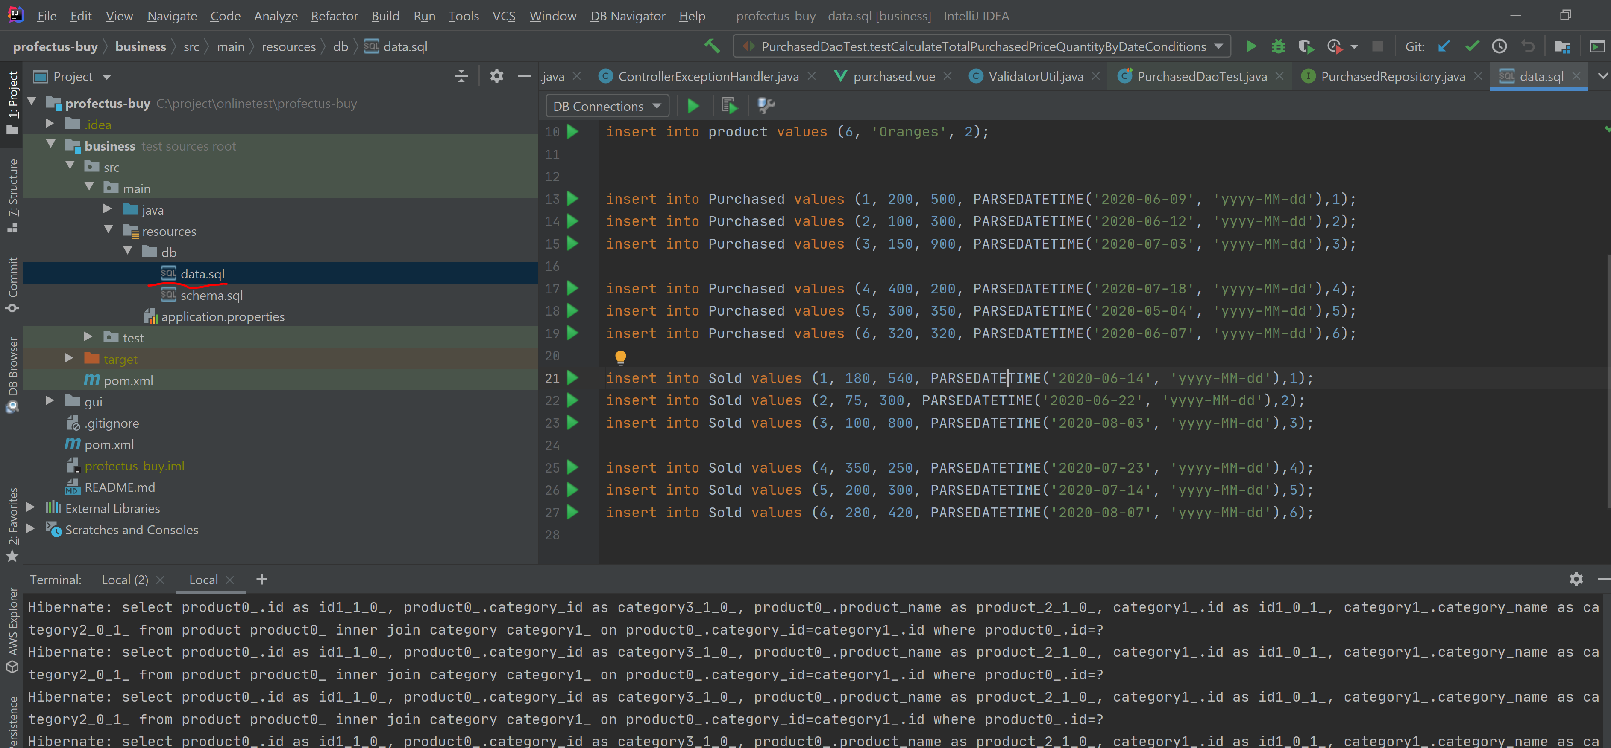

5. I have used H2 memory DB so all the data will be stored at memory instead of disk. Every time you run spring boot, test data will be loaded. If you start spring boot quite long time but have not used this app, the H2 data might be cleared by your os automatically. This rarely happened but might see when your machine got heavy load or crashed.

## Unit test:

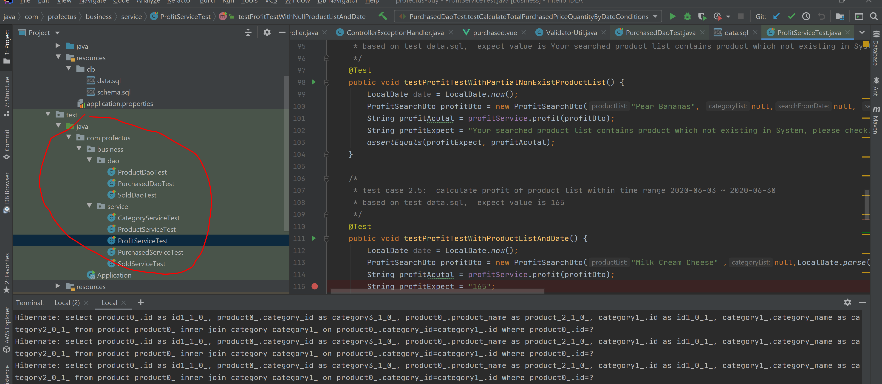

## Feedback

Please provide us feedback about the code challenge:

* how long did it take?

Around 23 hours

are the instruction clear?

Better to give developer the clear requirements how to calculate profit eg: mathematical formula

* would you make any modifications?

I am adding some validations on both front GUI and backend

* how was your experience?

Cool challenge. Need to consider the profit method before kick start.

## Challenge

Write a java spring web application which involves creation of 2 webpages (single page applications):

1. A page to enter in products:
   1. purchased with category, name, unique product code, date of purchase, quantity purchased, and purchase price
   2. sold with category, name, unique product code, date of sale, and sale price

For example:

**Purchased:**

1Dairy:

* Milk, 1, 9 Jun 2020, 200, $500
* Cream, 2, 12 Jun 2020, 100, $300
* Cheese, 3, 3 Jul 2020, 150, $900

2Vegetable:

* Bananas, 4, 18 Jul 2020, 400, $200
* Apples, 5, 4 May 2020, 300, $350
* Oranges, 6, 7 Jun 2020, 320, $320

**Sold:**

1Dairy:

* Milk, 1, 14 Jun 2020, 180, $540
* Cream, 2, 22 Jun 2020, 75, $300
* Cheese, 3, 3 Aug 2020, 100, $800

2Vegetable:

* Bananas, 4, 23 Jul 2020, 350, $250
* Apples, 5, 14 Jul 2020, 200, $300
* Oranges, 6, 7 Aug 2020, 280, $420

1. A page to calculate profits by date range, category, individual products, and purchase price. For example
   1. How much total profit did I make up to 30 Jul 2020?
   2. How much profit did I make on Dairy Products in 2020?
   3. How much profit did I make on Cream and Oranges in 2020?
   4. How much profit did I make on items that I purchased for less than $400 in 2020?

## Deliverables

* The source files and any tests, either:
  + zipped and mailed
  + on git or similar public source control repository
* Readme with instructions on how to build and run your application and assumptions made

## Notes

* UI may be created in any JavaScript framework.
* Backend/middleware should be in JAVA, Spring, JPA/Hibernate, Postgres as database
* Make any assumption necessary to complete the application (please note them).
* No authentication (login) necessary

## Evaluation Criteria

Your code will be assessed on the following criteria:

* Builds without errors or warnings
* Code design, code style, clean code, error handling etc
* Correct application of MVC pattern
* Comprehensiveness of unit testing
* Clean, simple UI that’s easy to use.

## Feedback

Please provide us feedback about the code challenge:

* how long did it take?
* are the instruction clear?
* would you make any modifications?
* how was your experience?